**Shneiderman's "Eight Golden Rules of Interface Design"**

(While Jakob Nielsen’s [10 Heuristics for User Interface Design](https://www.nngroup.com/articles/ten-usability-heuristics/) is probably the most popular set of heuristics out there, there are others.)

These rules were obtained from the text *Designing the User Interface* by Ben Shneiderman. Shneiderman proposed this collection of principles that are derived heuristically from experience and applicable in most interactive systems after being properly refined, extended, and interpreted.

To improve the usability of an application it is important to have a well-designed interface. Shneiderman's "Eight Golden Rules of Interface Design" are a guide to good interaction design.

**1 Strive for consistency.**  
Consistent sequences of actions should be required in similar situations; identical terminology should be used in prompts, menus, and help screens; and consistent commands should be employed throughout.

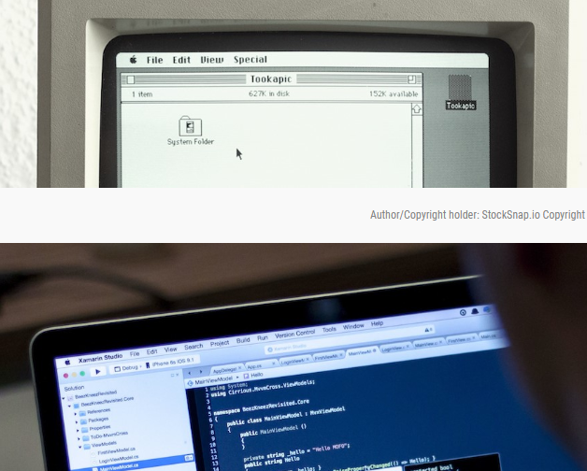

**Strive for consistency** by utilizing familiar icons, colors, menu hierarchy, call-to-actions, and [user flows](https://www.interaction-design.org/literature/topics/user-flows) when designing similar situations and sequence of actions.

**2 Enable frequent users to use shortcuts.**  
As the frequency of use increases, so do the user's desires to reduce the number of interactions and to increase the pace of interaction. Abbreviations, function keys, hidden commands, and macro facilities are very helpful to an expert user.



the demand for quicker methods of completing tasks. For example, both Windows and Mac provide users with keyboard shortcuts for copying and pasting, so as the user becomes more experienced, they can navigate and operate the user interface more quickly and effortlessly.

**3 Offer informative feedback.**  
For every operator action, there should be some system feedback. For frequent and minor actions, the response can be modest, while for infrequent and major actions, the response should be more substantial.

The user should know where they are at and what is going on at all times. For every action there should be appropriate, human-readable feedback within a reasonable amount of time. A good example of applying this would be to indicate to the user where they are at in the process when working through a multi-page questionnaire. A bad example we often see is when an error message shows an error-code instead of a human-readable and meaningful message



**4 Design dialog to yield closure.**  
Sequences of actions should be organized into groups with a beginning, middle, and end. The informative feedback at the completion of a group of actions gives the operators the satisfaction of accomplishment, a sense of relief, the signal to drop contingency plans and options from their minds, and an indication that the way is clear to prepare for the next group of actions.

 Don’t keep your users guessing. Tell them what their action has led them to. For example, users would appreciate a “Thank You” message and a proof of purchase receipt when they’ve completed an online purchase.

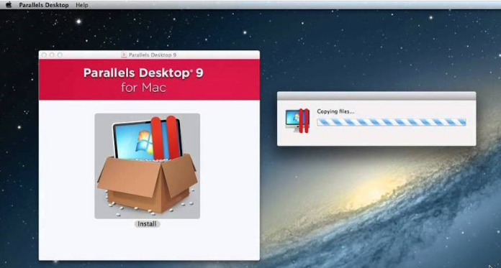

**5 Offer simple error handling.**  
As much as possible, design the system so the user cannot make a serious error. If an error is made, the system should be able to detect the error and offer simple, comprehensible mechanisms for handling the error.

No one likes to be told they’re wrong, especially your users. Systems should be designed to be as fool-proof as possible, but when unavoidable errors occur, ensure users are provided with simple, intuitive step-by-step instructions to solve the problem as quickly and painlessly as possible. For example, flag the text fields where the users forgot to provide input in an online form.

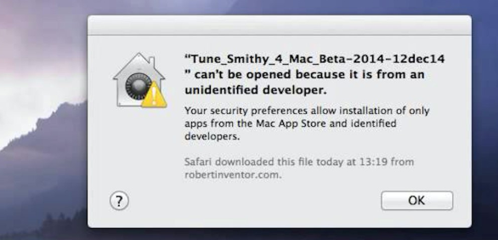

**6 Permit easy reversal of actions.**  
This feature relieves anxiety, since the user knows that errors can be undone; it thus encourages exploration of unfamiliar options. The units of reversibility may be a single action, a data entry, or a complete group of actions.

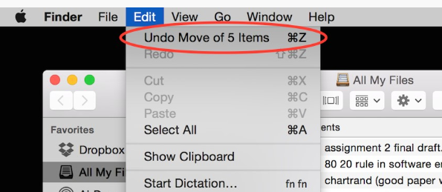

Designers should aim to offer users obvious ways to reverse their actions. These reversals should be permitted at various points whether it occurs after a single action, a [data entry](https://www.interaction-design.org/literature/topics/data-entry) or a whole sequence of actions. As Shneiderman states in his book:

This feature relieves anxiety, since the user knows that errors can be undone; it thus encourages exploration of unfamiliar options.

**7 Support internal locus of control.**  
Experienced operators strongly desire the sense that they are in charge of the system and that the system responds to their actions. Design the system to make users the initiators of actions rather than the responders.

Allow your users to be the initiators of actions. Give users the sense that they are in full control of events occurring in the digital space. Earn their trust as you design the system to behave as they expect.

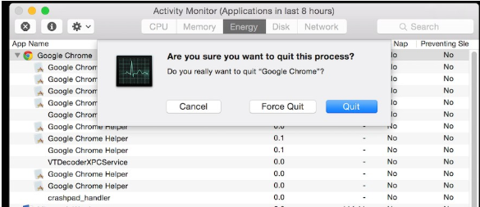

**8 Reduce short-term memory load.**  
The limitation of human information processing in short-term memory requires that displays be kept simple, multiple page displays be consolidated, window-motion frequency be reduced, and sufficient training time be allotted for codes, mnemonics, and sequences of actions.

Human attention is limited and we are only capable of maintaining around five items in our short-term memory at one time. Therefore, interfaces should be as simple as possible with proper information hierarchy, and choosing recognition over recall. Recognizing something is always easier than recall because recognition involves perceiving cues that help us reach into our vast memory and allowing relevant information to surface. For example, we often find the format of multiple choice questions easier than short answer questions on a [test](https://www.interaction-design.org/literature/topics/test) because it only requires us to recognize the answer rather than recall it from our memory. Jakob Nielsen, a user advocate who’s been called one of the “world’s most influential designers” by Bloomberg Businessweek has invented several [usability](https://www.interaction-design.org/literature/topics/usability) methods including [heuristic evaluation](https://www.interaction-design.org/literature/topics/heuristic-evaluation). Recognition over recall is one of Nielsen’s ten usability [heuristics](https://www.interaction-design.org/literature/topics/heuristics) for interface design.

